System Identification of a DC Motor Using ARX Model

Muhammad Husni Muttaqin  
Control Engineering and Intelligence System  
Bandung Institute of TechnologyBandung, Indonesia  
23223303@mahasiswa.itb.ac.id

*Abstract*— Behavior of the system can be characterized with System Identification by measuring on a system data response. This paper presents a comprehensive study of modelling brushed dc motor using ARX (Auto-Regressive with eXogeneous inputs) model. The Study encompasses several key components: Mathematical model of Brushed DC, ARX Model Equation, a detailed Research Methodology include experimental setup and methodology, input and output signal, validation signal, result, and conclusion. The findings of this study are concluded with discussions on the effectiveness of the ARX model and parameter in capturing the dynamics of the brushed DC motor and potential implications for future research.

Keywords—DC Motor, System Identification, Autoregressive-eXogenous, python

# Introduction

DC Motor play significant role for operation of machines and mechanical system. DC Motor have many problem like weak control and instability because of inaccuracy in calculating motor parameter. Extracting parameter accuracy is crucial. Parameter can be determined from identifying mathematical model [1]. There are two major class for identifying mathematical model, theoretical model and experimental model. Theoretical models describe complete description of system by physical and mathematical laws. Experimental models are based on input/output data [2]. In this articles using experimental modelling for identifying dc motor using ARX models in python. Python can easily integrate to microcontroller and sensors devices via serial, MQTT or even MODBUS devices like industrial grade sensors, drivers, and actuators trough python MODBUS library like pymodbus[10].

# Literature Review

## Mathematical DC Motor Model

DC Motor Model can be described as mathematical Modelling. DC Motor are separately excited. Power Supply is directly connected to the winding of motor. Fig. 1 is shown the DC Motor equivalent circuit. See figure 1

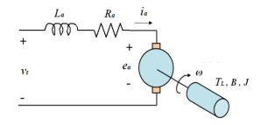

Figure 1: Brushed DC Motor equivalent circuit

Equation represented as electromechanical energy convention and torque balance rules. Electromechanical energy consist of two component, electrical and mechanical. The following is the electromechanical equation derivation below.

1. Electrical equation : Kirchoff Voltage Law

(1)

(2)

Ohm law:

(3)

Laplace transform of electrical equation :

(4)

(5)

Laplace transform for motor current:

1. Mechanical equation :

(7)

(8)

1. Electromechanical equation :

(9)

Laplace transform for electromechanical:

(10)

Equation 1-10 derives electromechanical equation from electrical equation to mechanical equation and mechanical equation if torque from electrical equation[3].

## ARX Model

ARX (Auto Regressive eXogenous) for a SISO (Single Input Single Output), ARX model are relationship between its input u(t) and output y(t) structure model is as the following expression:

(11)

A(q) represent the polynomial order of output, B(q) represent the polynomial order of input, and e(t) is residual error assumed to be gaussian noise, a and b are model coefficient [4] [5][8]

.

(12)

A(q) and B(q) are:

(13)

(14)

Predicted output equation:

(15)

Parameter for ARX equation:

(16)

(17)

# Research Method

## Experimental Setup

The computer is interfaced to the quanser DC Motor trainer include brushed dc motor and sensor via USB. QNET Software designed to generate control signal and read speed sensor from the motor. See figure 2

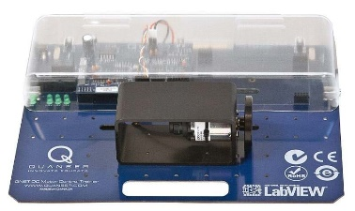

Figure 2: Quanser DC Motor Trainer

In this experiment a square and sine wave used during data collection for dc motor modelling. The data collected being export to excel and then input and output data proceed for system identification.



Figure 3: NumPy logo

After experiment data collected (input signal and output signal), data processed with ARX equation using python with NumPy library. NumPy support numerical operation with vector programming style where numerical operator operates on full array and frequently used by academic and the industrial community [6].



Figure 4: matplotlib logo

After input and output data proceed by NumPy using ARX equation. Data displayed in a cartesian graph using matplotlib library. Matplotlib is useful to develop a graphical application and suitable for two-dimensional application and three-dimensional application. Matplotlib provide variety chart like line, bar, scatterplots, and pie chart [7].

## Estimation of the DC Motor Parameters

Figure 5. Flowchart of System Identification

System Identification goal is developing an ideal model of a plant (DC Motor) from observed input-output data. Step by step of system identification are experiment and data collection, define a model structure, parameter estimation, model validation, and if model good and then system identification is done, but if the model is bad and then repeat the process from define a model structure [9].

## Input and Output of the system

1. Input and Output Signal

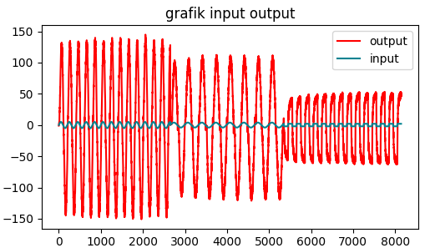

Figure 6. Input and Output Signal

Input signal on this study is sinusoidal signal with 5V Amplitude with 0.5 Hz Frequency, Sinusoidal signal with 4V Amplitude with 0.3 Hz Frequency, and Square Signal with 2V Amplitude and 0.5 Hz Frequency. For the output signal is the speed response of the motor depends the input signal.

1. Validation Signal

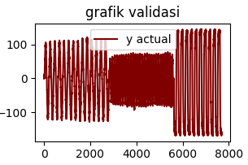Figure 7. Validation Signal.

# Result and Discussion

1. n=1, m = 0

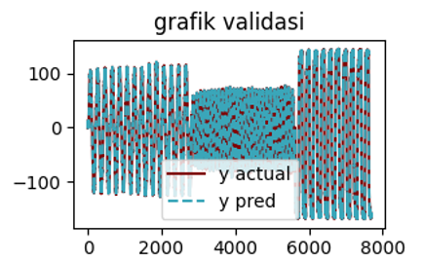

Figure 8. Validation Graph for n=1, m=0.

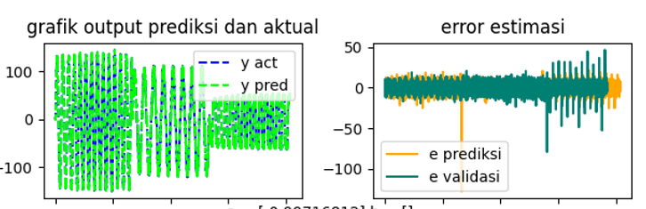

Figure 8. prediction output and actual include estimation error for n=1, m=0.

For n = 1 and m = 0, the value for parameter a is [-0.99716812], Mean Square Error Prediction is 31.41, and Mean Square Error Validation is 42.5445

1. n = 2, m = 0

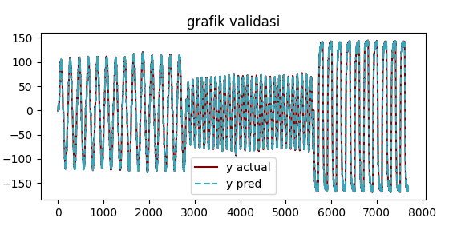

Figure 9. Validation Graph for n=2, m=0.

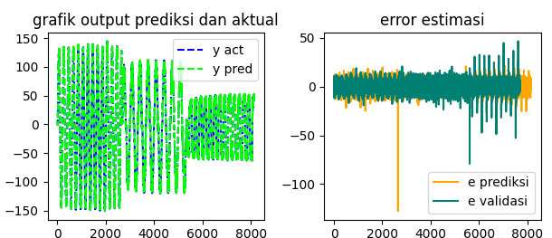

Figure 10. prediction output and actual include estimation error for n=2, m=0.

For n = 2 and m = 0, the value for parameter a is [-0.81779475 -0.17989271], parameter b is [], Mean Square Error Prediction is 31.41, and Mean Square Error Validation is 42.5445.

1. n = 2, m = 1

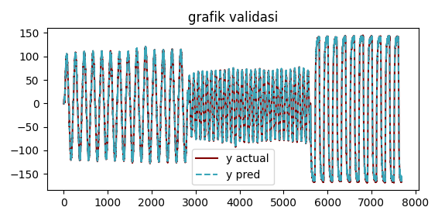

Figure 11. Validation Graph for n=2, m=1.

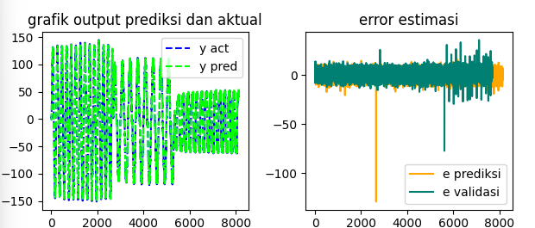

Figure 12. prediction output and actual include estimation error for n=2, m=1.

For n = 2 and m = 1, the value for parameter a is [-0.56128268 -0.34682127], parameter b is [2.58565435], Mean Square Error Prediction is 25.1996, and Mean Square Error Validation is 26.88585.

1. n = 2, m = 2

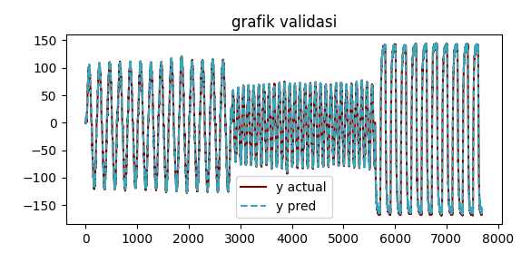

Figure 11. Validation Graph for n=2, m=2.

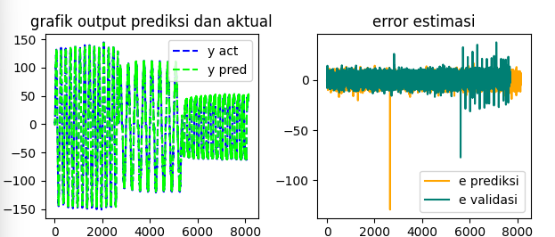

Figure 12. prediction output and actual include estimation error for n=2, m=2.

For n = 2 and m = 2, the value for parameter a is [-0.55918 -0.342419], parameter b is [0.69244412 2.0542053], Mean Square Error Prediction is 31.41, and Mean Square Error Validation is 42.5445.

# Conclution

In this study, we successfully identified the system parameters of a DC motor using the ARX (Autoregressive with eXogenous inputs) model. The research demonstrated the effectiveness of the ARX model in capturing the dynamics of the DC motor system, providing a reliable representation of the system's behavior based on input-output data. Best result on this experiment was n = 2, m = 1, with parameter a [-0.56128268 -0.34682127] and parameter b [2.58565435] with 26.88585 Mean Square Error (MSE) validation which is the smallest result.

##### References

1. Tolun. Omer Can, Tutsoy. Onder, “Estimation of DC Motor Parameters Using Least Square-Based Optimization Algorithm”, 2023 Innovations in Intelligent System and Application Conference (ASYU)
2. Mohlis. Salah-eddine, Sadki Said, “System Identification of a DC Servo Using ARX and ARMAX Models”
3. Pongfai. Jirapun, Assawinchaichote. Wudhicai, “Self-tuning PID parameters using NN-GA for Brush DC motor control system”, 2017 14th International Conference on Electrical Engineering/Electronics, Computer, Telecommunications and Information Technology (ECTI-CON)
4. Cheng. L, Cigada. A, Lang. Z, Zappa. E, Zhu. Y, “An output-only ARX model-based sensor fusion framework on structural dynamic measurements using distributed optical fiber sensors and fiber Bragg grating sensors”, Mechanical System and Signal Processing
5. M. Saifizi , M. Z. Ab Muin , Sazali Yaacob and M. S. Mohamad, “Comparison Of Arx And Armax Model For Thermoelectric Refrigerator”, International Conference on Mechanical Engineering Research (ICMER2013)
6. Troels Blum, Mads R. B. Kristensen and Brian Vinter, “Transparent GPU Execution of NumPy Applications”, 2014 IEEE 28th International Parallel & Distributed Processing Symposium Workshops.
7. J. Ranjani, A. Sheela, K.Pansi Meena, “Combination of NumPy, SciPy and Matplotlib/Pylab - a good alternative methodology to MATLAB - A Comparative analysis”
8. T. Söderström and P. Stoica, System Identification, Prentice-Hall International Series in Systems and Control Engineering. Prentice Hall, 1989.
9. M.S.Hussin, Azuwir M.N,Y.N.Zaiazmin, “Modeling and Validation of Brushless DC Motor”, 2011 Fourth International Conference on Modeling, Simulation and Applied Optimization
10. Muhammad Husni, Eko Budi Utomo, Diky Zakaria, Ade Gafar Abdullah, 2023, HMI SCADA using Python and QML Programming integrated to Outseal PLC, presented in The 4th International Symposium on Material and Electrical Engineering (ISMEE) 2023 (unpublished)

‘